Ridgeland Elementary School
College Motivation Week
March 27 –March 31, 2017

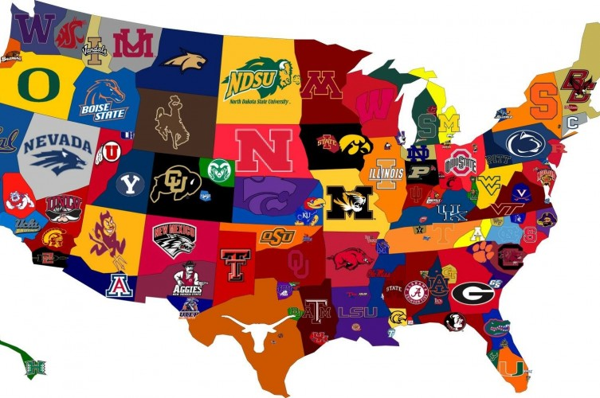

- Monday: My College Monday (Faculty wear college paraphernalia)
- Tuesday: Hats off to College (Students wear hats representing a college of choice)
- Wednesday: The Road to College Begins Here... (Each class will create a Banner representing their favorite college)
- Thursday: College Motivation Week Classroom Door Contest (Each Class with Decorate their doors).
- Friday: Tell me about College ... (Teachers and Guidance Counselors will do mini-lessons about college life and how students can benefit from attending college. Students can wear t-shirts representing a college of choice.
CAREER DAY 2017 will take place on Friday, March 31, 2017. Career Day Speakers will rotate to 4th-5th grade classes.
